Spencer Baptist Church
187 N. Oak Street
Spindale, NC 28160

Return Service Requested
Church Office: 828-286-2355
Fax: 828-286-4496
e-mail address: spencer@spencerbaptist.com

Non-Profit Organization
U.S. Postage Paid
Permit #5
Spindale, NC 28160

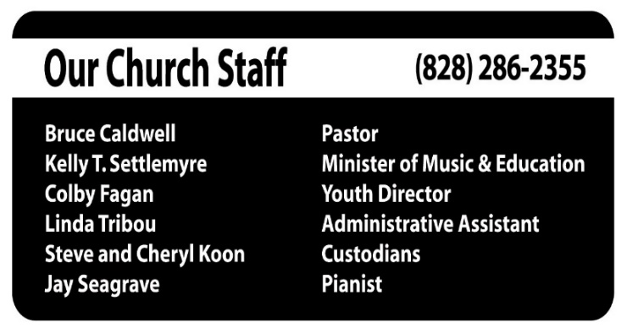
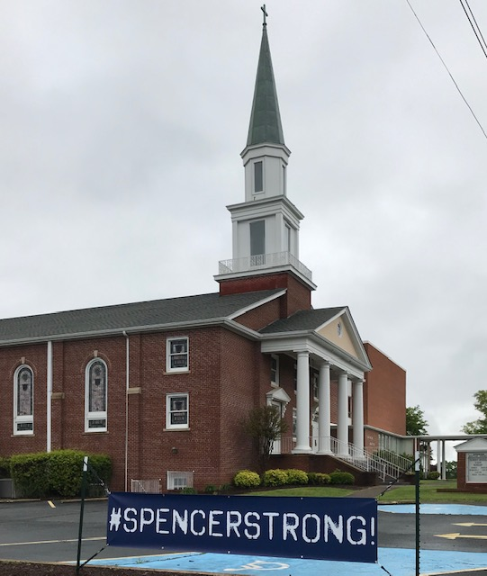

Join us in person or online. We are broadcasting our worship service live each Sunday at 11 AM on Facebook Live and on local radio
WCAB 590 AM or 100.9 FM.

Subscribe to our YouTube channel. Go to Youtube.com and search for Spencer Baptist Church. After you click on our church name,
please click “subscribe.”

Sunday Schedule for January*

10:00 – Life Groups for all ages
11:00 – Morning Worship
5:30 –Activities for Children & Youth

*Schedule is subject to change.

Volume 1 January 2024 No. 15

No. 13

Night to Shine
Friday, February 9, 2024

It’s time to sign up to help with the 2024 Night to Shine! We are looking for volunteers in multiple areas: decorating, registration, traffic control, personal buddies, greeters, and more. If you can help with this amazing night, please see Kelly or call the church office to let us know. Our biggest need will be personal buddies to guide our special guests throughout the evening. If you wish to help with the financial aspect of Night to Shine, you may make contributions at any time by marking your check “Night to Shine.”

Now is a great time to consider joining one of the Music Ensembles at our church! The New Year brings new beginnings for our groups.
Our Adult Choir meets at 7 PM each Wednesday.

Our Handbell Choir meets at 9 AM on Sundays.

Our Children’s Groups meet at 5:30PM on Wednesdays and 5:30PM on Sundays.

If you have any questions, please ask Kelly. All groups will be back in full swing during the 2nd week of January.

New for 2024 – the Spencer Praise Team! If you would like to be a part of a newly formed praise team, please see Kelly or Jay. We are looking for instrumentalists and vocalists to fill out the group. Rehearsal times will be announced later this month.

Centrikid 2024
It is already time to begin planning for summer camps! Our kids will be going to Ridgecrest for Centrikid again this year during the week of June 10. There are limited spots for camp each year, and a $50 deposit will reserve your child’s space. The deposit is refundable through Feb. 15. After that, the deposit will be nonrefundable. Centrikid is open to kids who are currently in grades 3-5. If space is available, those currently in 2nd grade may also sign up.

If you would like to sponsor a camper this year, the total cost for one child is $350. Full and partial donations are always helpful! We will have multiple children who need assistance in order to attend camp.

College Students – Take Note!
If you will be attending college in the fall, there are several scholarship opportunities you may want to take a look at! The NC Baptist Foundation (now known as Provision) offers multiple scholarships for students who are members of NC Baptist Churches. You can visit their website for specific information (https://www.provision.org/scholarships) or you can talk with Bruce, Kelly or Colby to learn more. You must complete a FAFSA before applying. The deadline to apply for these scholarships is Feb. 15.

Jan. 7 Jan 14
Pat Tomblin Curtis Rice
Bostic Fairhaven 240 Prince St
149 Fairhaven Dr Spindale, NC 28160
Bostic, NC 28018

Jan 21 Jan 28
Lois Hodge Nora Greene
3392 Pearidge Rd Brookdale Assisted Living
Bostic, NC 28018 493 Piney Ridge Road
Forest City, NC 28043

Caring Hearts Sewing Group
We will meet on Monday, Jan. 8th at 10:00am

Stewardship Meeting Stewardship Committee will meet Tuesday, Jan. 9th at 6pm.
Deacon’s Meeting
Deacon’s will meet Tuesday,
Jan. 9th at 7pm.

Circle of Sisters
Circle of Sisters will meet Tues., Jan. 16th at 6:30pm

Nursery Volunteers
Jan 7: Haley Turner, Tyler Sims,
Lisa Harmon

Jan 14: Jackie Connor & Kelli Beavers

Jan 21: Olivia Fagan, Ann Caldwell

Jan 28: Heidi & David Odom, Karen LaBreche

*please help us provide a safe nursery environment for our younger children. The nursery area is designed for children who are not yet in kindergarten. Older kids should not come to nursery without approval.

Safety & Security Volunteers

Jan. 7: Greg Settlemyre, Doug Bright

Jan 14: Jeff Murray, Billy Waters

Jan 21: Scott Sims, Glen Harmon

Jan 28: Tyler Sims, Kenneth Head

Jan 7 Jan 14
Junior Montgomery Sierra Clark
145 Sapphire Dr 555 Paul Hardin Dr #255
Rutherfordton, NC 28139 Chapel Hill, NC 27514
Isothermal Community UNC Chapel Hill

Jan 21 Jan 28
Ty’Nia Watkins Zhavion Washington
Scott Hall 307L A 615 Pinkwood Dr
1000 East 5th St Rutherfordton, NC 28139
Greenville, NC 27858 Isothermal Community
East Carolina University

Senior Adults Lunch
Tuesday, January 9th at 10:30am
What better place to eat a good meal with good friends is there than Ken & Mary’s? We will leave the church at 10:30am to go to Shelby to eat.
Join us for a great time!

Senior Adults Evening Meal
Thursday, January 25th at 5:00pm
Join us as we go to Countryside BBQ in Marion for a great meal on Thursday, Jan. 25th.
We will leave from the church at 5pm.

OPERATION CHRISTMAS CHILD 2024
January's item of the month is Personal Care Items. Personal care items include but are not limited to the following: Nail clippers, hair combs/brushes, hair ties and other accessories, wash cloths, bandaids (fun colors and designs), blunt utensils, toothbrush and covers, (NO toothpaste). If you have other items you'd like to donate that do not fall into the category of "personal care" you are still more than welcome to bring those things in. The big red bin will be located outside of the office! If you're out shopping, don't forget to check the clearance aisles for potentially great deals! As always, please let me know if you have any questions! Thank you - Kelly Owens

Mission to Kentucky Update
- Right now, we don’t need any clothes. The folks at the ECCO center said they had enough clothes for a while. Please take clothes to Yokefellow, Habitat ReStore, Pilgrims Pathway or Hospice.
- We can always use good furniture & houseware items. Please make sure they are boxed and are ready to stack in the trailer. If they are not usable, please throw them away.
- If you bring items for Kentucky, please take them to the “Kentucky Room” or let the staff know. Please do not leave items in the hallway.
- We will let you know when they are in need of more clothes.

Thanks for all you give! It really makes a difference in the lives of a lot of people. Bruce

Lottie Moon Christmas Offering for International Missions

Our Church Goal: $9,000
Donated: $10,646.00
Thank you for being so faithful to meet and surpass our Lottie Moon challenge. The generosity of you giving will go a long way to serve the needs of our international missionaries. Every dollar given is used for the ministries they provide to the unreached people of the world. Jody Hartman, WMU Director

Spencer Church offers deepest Christian condolences to the family of Elizabeth (Liz) Alexander.

Yokefellow
Yokefellow is requesting donations of maple syrup for the months of January – April. Thank you!

Serving will begin at 6pm in the Family Life Center.

Please reserve your meals before
noon on Tuesdays.
We need to know how many meals to prepare. Please call the church office or reserve your meals on our
website or FB page.

Jan 3 Pulled BBQ Chicken, Potato Wedges, Slaw & Rolls
Prepared by: Cindy Moris, Jane Ronan, Kelli Beavers, Wendy Ankrom

Jan 10 Salisbury Steak, Mac & Cheese, Green Beans, Rolls
Prepared by: Ed & Lillian Toro, Jackie Connor,
John Stevens

Jan. 17 Chicken Cordon Bleu, Mashed Potatoes, Green Beans, Rolls
Prepared by: Adult Choir

Jan 24 Meatball Subs, Fruit, Chips
Prepared by: Come as You Are Wednesday Class

Jan 31 Loaded Nachos
Prepared by: Spencer Deacons

Spencer Youth Winter Retreat
January 26 – 28th
Top Notch Lodge, Sevierville, TN
This is an opportunity for youth to recharge their spiritual batteries, discover new thoughts about themselves and their relationship with God.
Please see Colby ASAP for details. Space is limited.

Green River Baptist Association
January Quarterly Association Meeting
Monday, January 29th, 2024 at 6:45pm
Oak Springs Baptist Church
2591 Rock Road, Rutherfordton, NC 28139
Preacher: Dr. Keith Stephenson
Pastor of Second Baptist Church

